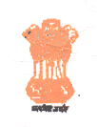Government of India  Central Water Commission  RIVER DATA DIRECTORATE | 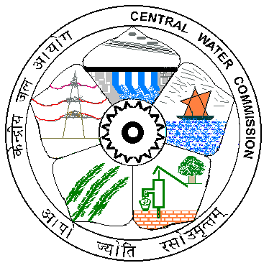

No.9/3/2006-RDD/ 2364 68 Dated: | 26.08.2015
Auction Notice
On behalf of the President of India, the Departmental auction for “Disposal of old and unserviceable materials” (Sl.No.1 to 7) to be made by the undersigned as per the Schedule enclosed and terms and conditions as below.
The sealed tender should be dropped in the tender box of the Deputy Director, R.D. Dte., CWC, 2nd Floor, Wing-4, West Block-1, R.K.Puram, New Delhi on or before 14.09.2015 at 15.00hrs and will be opened on the same day at 15.30 Hrs. Intending bidders may present at the time of opening of auction bid.
Every bidder has to attach his bid with an Earnest money amounting to Rs.1000/- (Rupees one thousand only) in the form of Cash/TC/FDR/Demand Draft/Pay order in the favour of Deputy Director, R.D.Dte., CWC, New Delhi. The bids without earnest money shall be invalid & summarily rejected.
The earnest money will be refunded back to all the bidders except the two highest bidders after completion of the auction.
The successful bidder will have to deposit full amount of bid within 3 days.
The successful bidder has to lift/remove the materials from the office premises within 2 days of making full payment failing which 2% of bid value per day will be charged extra after the stipulated time.
In case of failure in depositing the full money and non-lifting1of the material within the stipulated period, earnest money will stand forfeited and the offer shall be extended to the next highest bidder.
The Director (RDD) reserves the right to accept or reject any or all the bidder without assigning any reason thereof.
The material are available in the office premises of the Office of the Deputy Director, R.D. Dte., CWC, 2nd Floor, Wing-4, West Block-1, R.K.Puram, New Delhi on “AS is where is Basis” and can be inspected during all working days between 10.00 AM to 5.30 PM.

Sd/-

(A.K.Mittal)
Dy. Director (RDD)

Copy for information to,

- The Assistant (A/C section), R.D.Dte., CWC, New Delhi.
- Notice Board, RD Dte, CWC, New Delhi.
- M/s Sharma Traders, D2/97, Mayapuri, Phase-II, New Delhi -110064
- Shri Narendra Joshi, E-47, West Patel Nagar, New Delhi - 110008
- M/s Cerebra Integrated technologies Ltd, Plot No. 422/2, 11th Cross, 4th Phase, 2nd stage, Peenya Industrial Area, Bengalore – 560058

List of Survey reported T&P articles.

Sl.No | Description of Articles | Number or Quantity
 | Desert Coolers | 3 Nos
 | Nexus Offline UPS500VA/700VA | 1 No
 | UPS500VA | 1 No
 | Executive low back revolving Chairs | 6 Nos
 | Metal table sunmica top 1220x610x762 | 3 nos
 | Metal table sunmica top 1370x680x762 | 3 nos
 | Steel visitor chairs | 3 nos

Dy. Director
RD Dte., CWC, New Delhi

